Sport Coach (Casual)
Concordia Campus (Highgate)
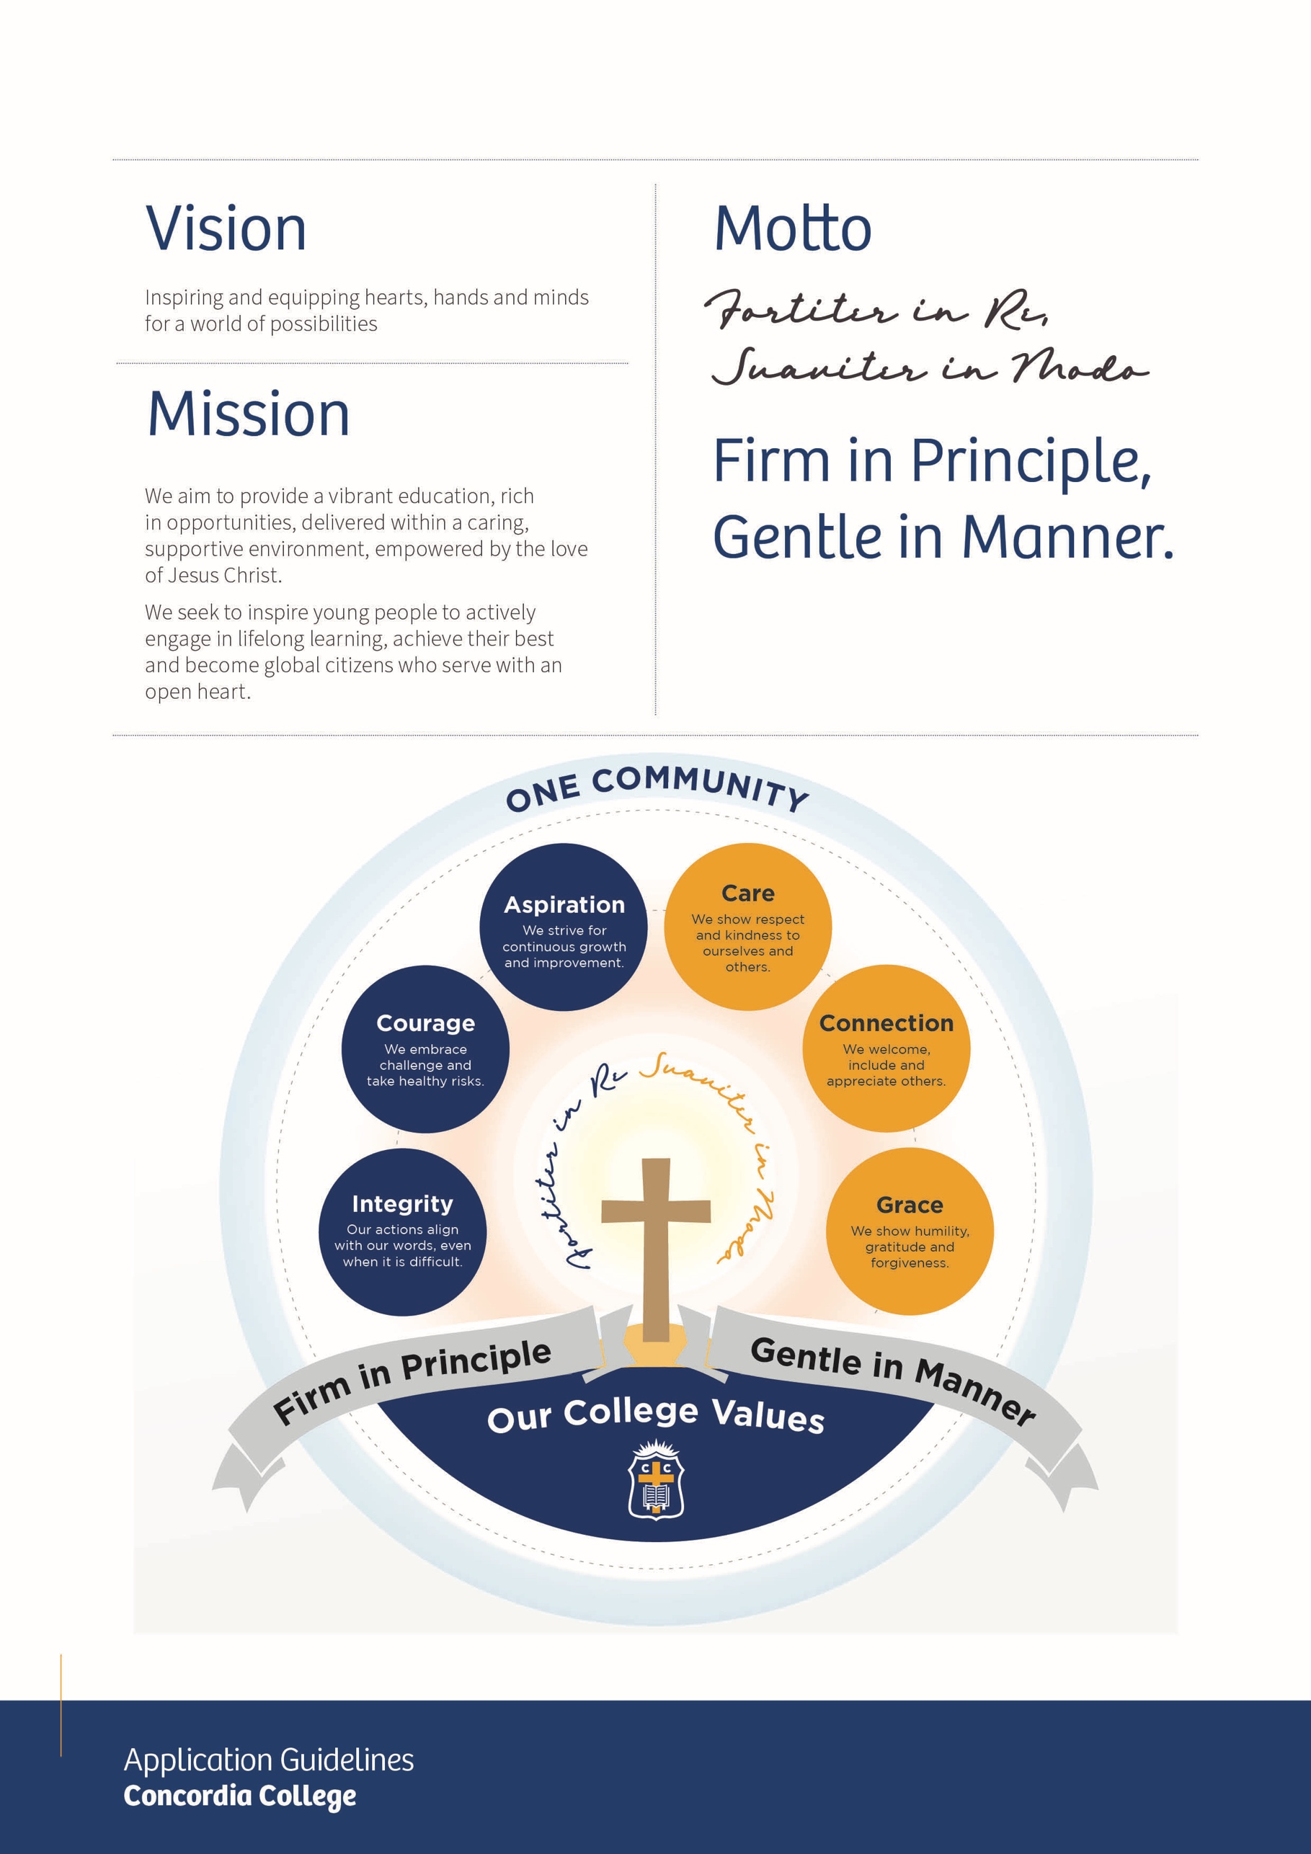

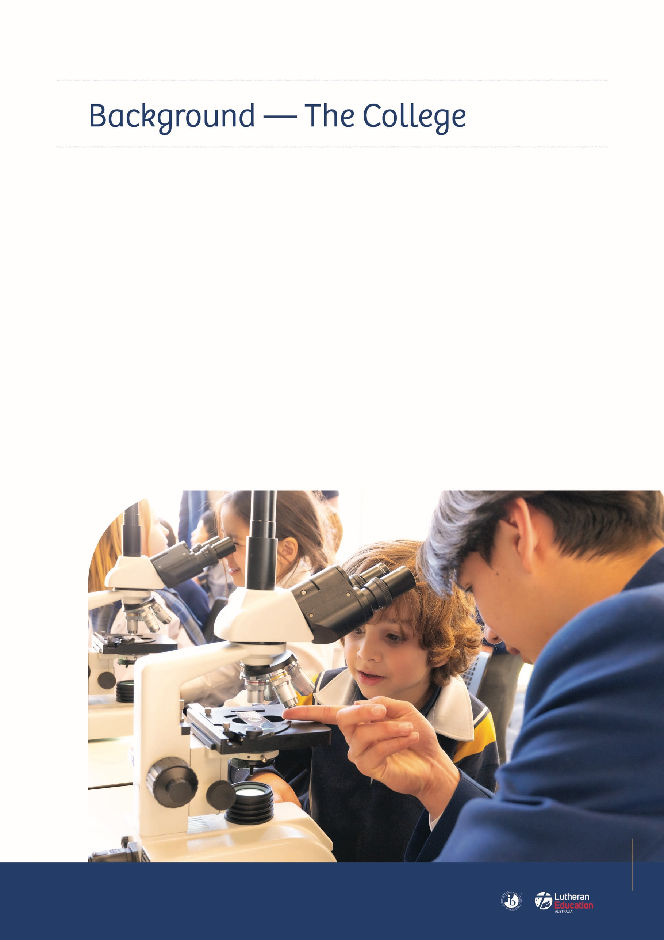
Concordia College has a rich history as an academic and caring school, encouraging and supporting young people to be successful, independent learners.
Our school was established in 1890 in Murtoa, Victoria as a boys’ college and training ground for future pastors and teachers. Fifteen years later, it moved to Highgate, a beautiful leafy suburb just 5km southeast of Adelaide’s CBD.
In 2016, Concordia College and St John’s Lutheran School in Highgate, joined together as one College (ELC to Year 12). We amalgamated with St Peters Lutheran School at Blackwood, adding a third campus in January 2023.
- St Peters Campus, Blackwood – ELC to Year 6
- St John’s Campus, Highgate – ELC to Year 6
- Concordia Campus, Highgate – Year 7 to Year 12
The ongoing development of the IB curriculum framework, the Australian curriculum, SACE, VET and the continuing exploration of new ways to use digital technologies in support of student learning are important components of the Strategic Plan of Concordia College. All students have access to a digital device. Current enrolment is approximately 550 students from ELC – Year 6 and 900 students from Years 7 – 12.

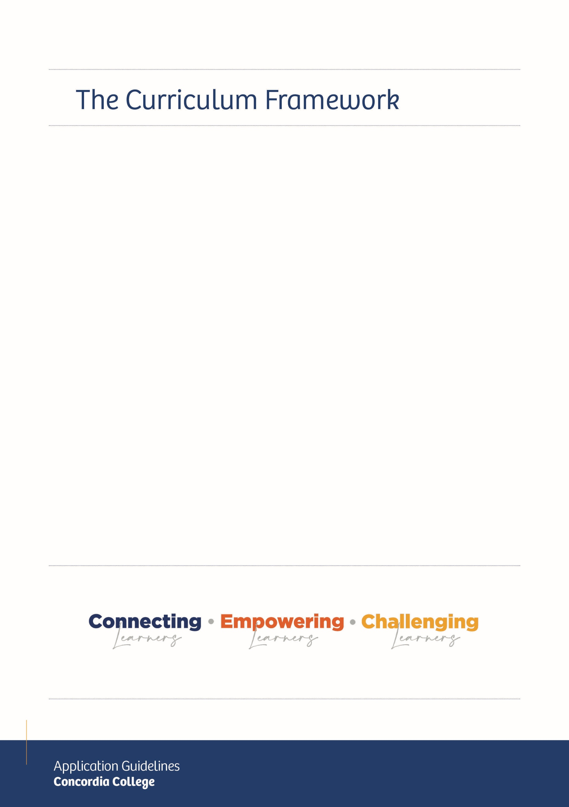
ELC
The Early Learning Centres (ELC) provide a safe and nurturing environment and is the first step into education at Concordia College from 3 years of age.
YEARS R – 6
The St John’s Campus offers the International Baccalaureate Primary Years Programme (IB PYP). It aligns with the Australian Curriculum.
The St Peters Campus offers the Australian Curriculum.
YEARS 7 - 9
The Middle School has offered the International Baccalaureate Middle Years Programme (IB MYP) since 2000. It aligns with the Australian Curriculum.
YEARS 10 – 12
Students complete the South Australian Certificate of Education (SACE). VET opportunities are supported.
These curriculum frameworks all promote student-centred learning and the development of independent learning skills designed to equip young people with life-long qualities that extend beyond the classroom into the community. Many school-organised service activities support this.

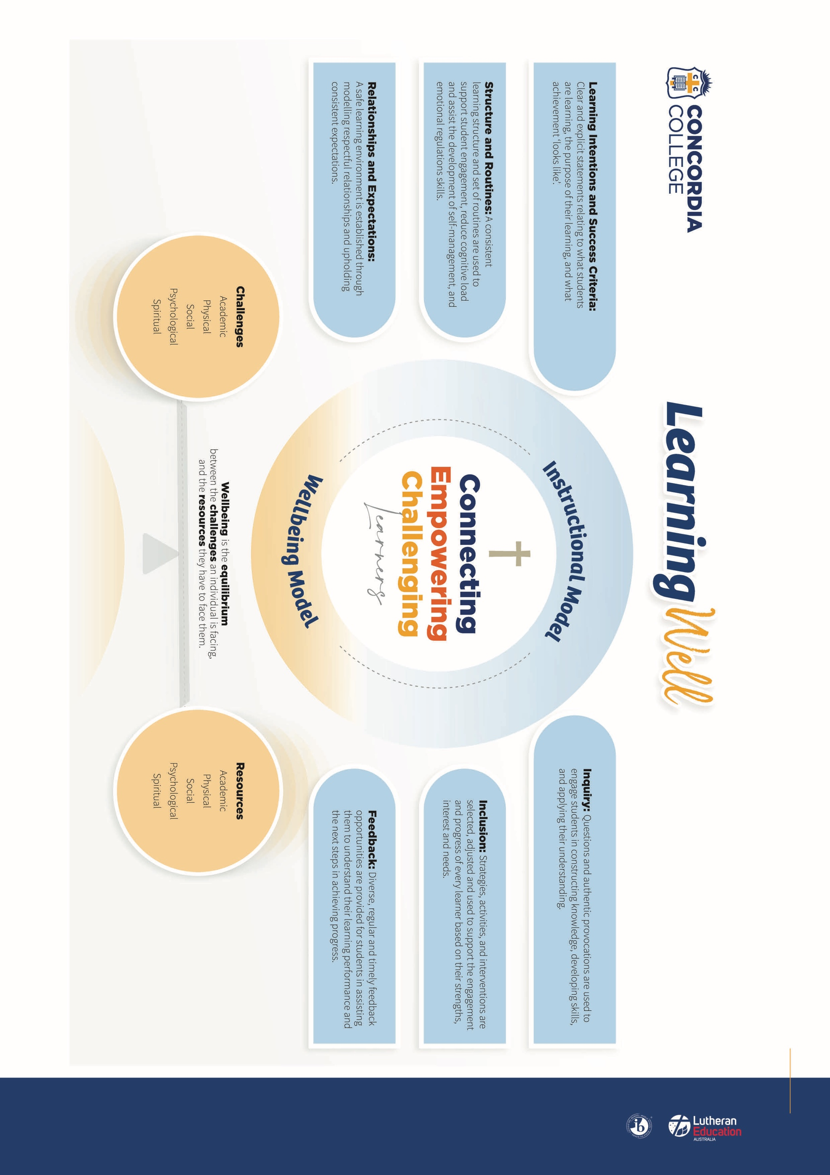


School Culture
Concordia College supports an environment that encourages the growth of each individual’s spiritual, intellectual, cultural, social and physical capabilities.
The heart of Concordia College is expressed in our motto; Firm in Principle, Gentle in Manner. The education and growth of the whole person is central to the purpose of the College and is realised through high expectations within a culture of openness and forgiveness in a Christian community.
Concordia College is an inspiring school environment with professional, caring teachers who provide a firm foundation for students to engage with their learning and build relationships. We believe this is vital in allowing them to strive to achieve their best. This in turn, enables students to be positive contributors to the world through service to others, both locally and globally.

Sport at Concordia College
Concordia College is highly successful in a range of sports, entering teams in national and state-wide sports competitions such as Basketball, Netball and Volleyball. Our Basketball program has had a particularly proud history, having won several State Championship titles. In recent years, our Volleyball program has been steadily building with a number of excellent results, including three consecutive Senior Girls’ premierships.
This sporting excellence is underpinned by our emphasis on participation. Students of all abilities are encouraged to participate in at least one of our many sports. We offer programs for both first time players and the more experienced.

Why Join Concordia College?
At Concordia College, you’ll be part of a vibrant, values-driven school community that supports both your professional journey and personal wellbeing.
- Inspiring Students
Be energised by curious, motivated and engaged learners who are eager to grow and thrive.
- A Community That Cares
Experience the warmth of an authentic, inclusive and supportive environment made up of passionate students, dedicated families and committed staff.
- A Team with Purpose
Work alongside experienced and driven professionals who share a deep commitment to delivering excellence and enriching the student experience.
- Investing in You
Grow your career through generous professional learning opportunities that reflect our strong belief in lifelong development.
- Outstanding Locations and Facilities
Enjoy working in beautiful settings at Highgate and Blackwood, featuring state-of-the-art sports and learning facilities.
- Wellbeing Matters
We prioritise the wellbeing of our staff by fostering a culture that values a healthy approach to work and life, supports opportunities to recharge, and actively listens to and respects staff voice.


Sport Philosophy
At Concordia College, sport transcends the typical definition of extra-curricular activities and is embraced as a vital component of the co-curricular framework. This approach recognises sport as an essential element that enriches the curriculum and enhances the overall learning journey of students. While some extra-curricular activities can be somewhat peripheral in regard to their influence on the holistic education of a student, co-curricular activities are deeply interwoven with the curriculum, fostering growth in social, physical, and leadership competencies.
This role is central to fostering a positive and high-performing sporting environment at Concordia College. Coaches are encouraged to provide leadership and inspiration to students while upholding the school’s values and commitment to excellent in sport.

Sport Coach (Netball and/or Soccer)
Casual
Weekday mornings and/or afternoons trainings and/or matches, and Saturday morning matches
Commencing as soon as possible

Concordia College is actively seeking coaches for 2026 across Netball and Soccer.

Concordia College is seeking passionate and enthusiastic sport coaches to provide high-quality coaching and contributing to the development of the school’s sporting program. Coaches are responsible for ensuring that all activities align with the College’s values and vision while fostering player growth, team success, and enjoyment. Coaches report directly to the Sport Coordinator.
It is mandatory that all coaches hold a current WWCC, RRHAN-EC (Masterclass) prior to commencing a coaching role with Concordia College.

Applicants must be at least 18 years of age.

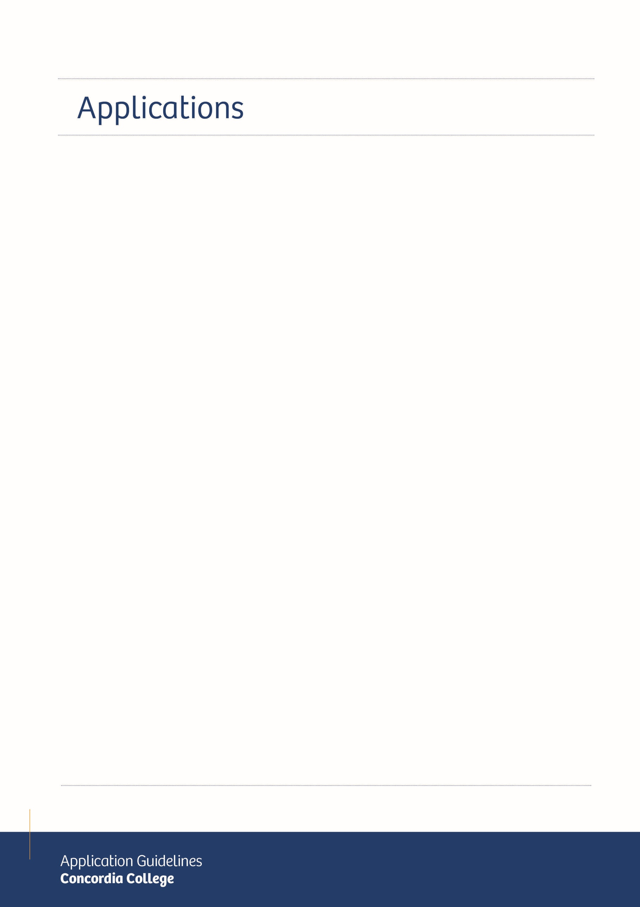
The Role Description and Application Form for this position can be accessed on the College website, www.concordia.sa.edu.au, under ‘About’ / ‘Employment’. If there are any questions about the position or the application process, please contact Reception, who can put you in touch with the appropriate person.
Applications close 9.00am Thursday 2 April 2026, however applications will be considered as they are received, so please apply as soon as possible.
Applications will be accepted via email only to employment@concordia.sa.edu.au.
Please quote “Sport Coach – Your Name” in the subject line of your application email.
Applications should be addressed to:
Mr Paul Weinert
Head of College – Concordia College
24 Winchester Street
Highgate SA 5063
Applications should include the following:
- a completed Concordia College Employment Application Form
(available from the College website)
- a brief covering letter outlining why you are interested in the opportunity to join Concordia College and how we would see the Learning Well framework embedded in your work in our Community
- an up-to-date resume which includes a chronological summary of qualifications and positions held
- please attach a copy of your current RRHAN-EC, WWCC, First Aid and other relevant certificates.


The selection panel regards the selection process as a confidential two-way communication process involving applicants and the panel.
The selection panel reserves the right to contact relevant referees contained in the application form and any who have not been nominated by the applicant. Applications that are incomplete may not be considered further.
Applicants will be selected for interview by the selection panel based on the assessment of their written application and details included in the general application form completed by all candidates.
Applicants selected for an interview will be provided with additional information prior to the interview.
Applicants should be aware that interviews will be conducted at the Concordia College on dates to be determined by the selection panel. Interviews with interstate applicants will be conducted via video call.
In the first instance the respective merits of each of the applicants will be assessed against their written application. The interview panel will assess responses to questions asked at the interview, and performance on any other task which may form part of the selection process.
The selection process will be conducted by the selection panel with complete confidentiality.
Applicants should note that they may be required to undergo medical and/or psychological assessment prior to being appointed to the position.


